BT-CULTURAL PRESENTS

"THE WORK OF THE SICILIAN PUPPETS"

The event will be held inside the Cine-Teatro Santa Barbara reopened for the occasion, curated by CentroStudiArtiVisive and Compagnia Thalìa, at 23.30

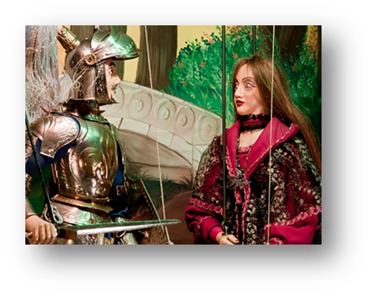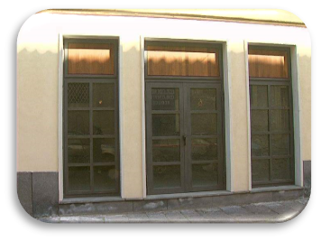



A particular spectacle that will treat the reinterpretation of the Greek tragedy of

"The Seven Against Thebes" set in scene through the use of puppets.

The story narrated, starting from the background of the family descended from Oedipus, will focus on the fight between the two brothers Polynice and Eteocles and the absurdity of violence, which eventually will lead to the fall of a balance.

The choice to use the work of puppets as a means of representation for a classical tragedy reflects the willingness to demonstrate its contemporaryity.

Always able to narrate events of heroes not only chivalry but also classics, the work of the puppets is born as a valve of the people's outburst, becoming so in time, a pretext to reflect on many questions of human and social nature.

To cure the realization of the show will be the CentroStudiArtiVisive, study formed with the will to unite the different but complementary skills of three professionals in the field of visual arts, an architect, a scenographer and a photographer. It is responsible for preserving and maintaining this Sicilian tradition alive.

The company is active on the territory Paternese and not only, and this year is engaged in an intense theatrical season that will go from May 2017 to February 2018.



 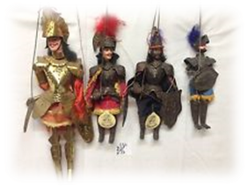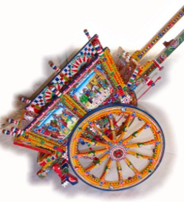

INPUT: 8€ ADULT

CHILDREN UP TO 12 YEARS, FREE