***CULTURAL EVENT: ‘’BACK TO PREHISTORY’’***

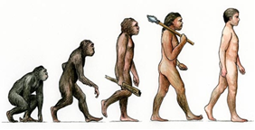

On 19-20 may at the "Villa Moncada" of Paternò will be held the cultural event that will affect all those who want to revive, through theatrical performances, games, and recreational activities, the prehistoric life.

Opening gates: 10:00 hours

Admission Ticket: €5 adults; Free entry for children.

The event will include:

 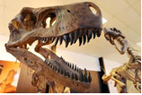 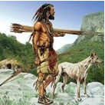

• The representation of a prehistoric scene with high-skilled actors who will be able to entertain young and old thanks to the prehistoric costumes, music, lights that revive the atmosphere of the past, letting everyone enter the heart of the scene.

• Playful and recreational workshops that will include the vision and use of some struments used in antiquity, which will allow to implement pleasant and recreational activities that will affect various age groups.

• Our staff will make available the struments that will allow you to implement the activities and the commitment to entertain the children who will see them committed to acting, playing, having fun.

• Various booths will be used for the exhibition of images representing prehistoric scenes of life.

• You will be able to visit the main monuments of the city by a shuttle service that provides an additional cost of €5 (includes a visit to the historic hill of San Marco).

Also available are:

 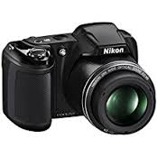 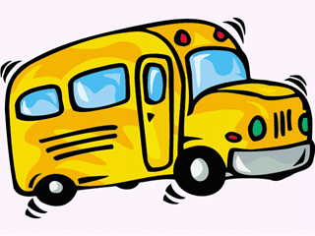

REFRESHMENT PHOTO SERVICE SHUTTLE BUS SERVICE

***How to reach us?***

Paternò is a city very accessible:

* ***By car:*** 

***From Palermo:***

From the A19 PA-CT motorway, exit at Gerbini

***From Catania:***

SS 121 (Expressway to Adrano), exit directly to Paternò

***From Messina:***

From the A18 ME-CT motorway, take the “Tangenziale” ovest of Catania and exit at Misterbianco you will find the SS 121

* ***By bus:*** 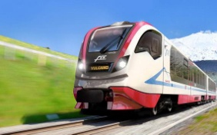

For who choose to reach Paternò by bus, we report the service guaranteed by the railway “**CIRCUMETNEA FCE”**

There is a Timetable which could be changed daily:

6.00-07:05-8.30-9.30-10.30-11.20 (*)-12.00 (*)-12.30-13 (*)-13.30 (*)-14.00 (*)-2:20-15.30-16.30-17.30-6.15-19.00-19.30-20.00-21.00

(*) Quick run service-service suspended on Sunday days and holidays

* ***By train:***

You can also reach Paternò, **by train**, with the railway **“CIRCUMETNEA FCE”**, fascinating path on track around Mount Etna.

* **The presence of the international airport of Catania-Fontanarossa** will allow the arrival of all those who want to reach us from all over the world.

From there there will be a shuttle bus which with additional costs will make you reach the desired places.

