CULTURAL EVENT

"ARTISTS FOR A DAY"

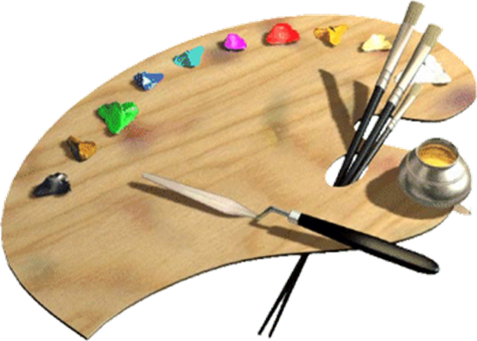

The event that we propose is dedicated to the day of art, such as to give to artists and enthusiasts, the opportunity to give the creativity and to admire a diverse exhibition of paintings of the most famous painters all over the world.

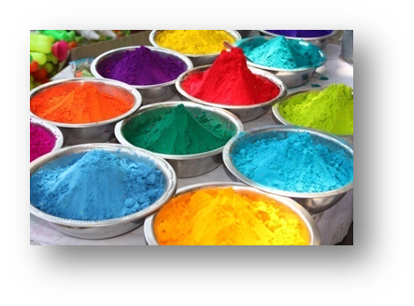

**The exhibition will be exposed outside the Norman castle and also internally, seizing the opportunity to admire one of the most important fortresses of the city.**

**Ticket: €5 per person for adults**

**For children: Free entrance**

***The event includes:***

• Exhibition of paintings and illustrations by our qualified staff

• Recreational activities for adults and children concerning the explanation of the pictorial techniques for the realization of the framework

• Recreational spaces dedicated to the creation and painting of a hypothetical framework, in which all the struments useful for the realization will be made available.

• Stands with music and exhibits of objects for sale

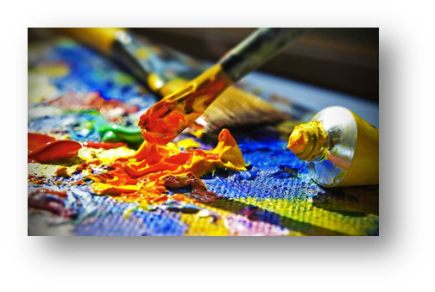

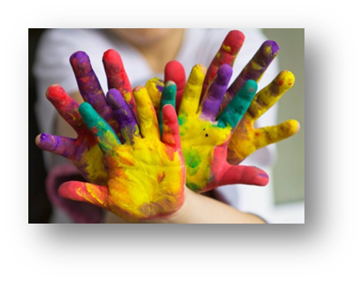

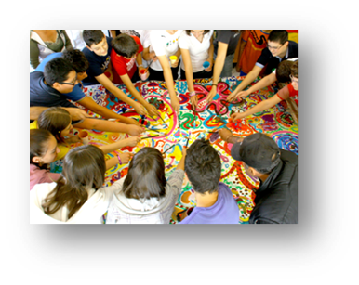

For further information please do not hesitate to contact us:

www.btculturalo.it

btcultural@gmail.com

095-543289

3459823976

ARE AVAILABLE:

 

REFRESHMENTS PHOTO SERVICE